StarsStreaming Project Deliverables Overview

Disney.Com IA Sitemap

StarsStreaming User Persona

StarsStreaming FAQs

StarsStreaming New User Email Memo

StarsStreaming Start-up Guide

StarsStreaming Style Guide

StarsStreaming Application Release Notes

………………………………………Pg. 2

………………………………………..Pg. 3

……………………………………..Pg. 4, 5

..………………………………………Pg. 6

……………………………………..…Pg. 7

………………………………………Pg. 8

……………………………………..…Pg. 9

………………………………………Pg. 10

**Project Deliverables Overview**

Overview tables summarizing deliverables’ parameters, timelines, and formats used as well as projected project hours

### **Deliverable Dashboard Table**

| **Project** | **Status** | **Related files** | **Timeline** |
| --- | --- | --- | --- |
| Disney.Com Sitemap/IA | Launched | [IAChartDisneydotCom.drawio.pdf](https://drive.google.com/open?id=1FhFcTQx9uLimFSTYkb6tj4IysDCPpKgM) | 04/28/2024  Completed on Time |
| StarsStreaming User Persona | Launched | [User Persona](https://docs.google.com/document/u/0/d/1Wnr-1Nr1vucYJJssBqPsJDrWv9nHdSNwVB-4Bm-7POI/edit) | 06/03/2024  Completed on Time |
| StarsStreaming FAQ | Launched | [FAQ](https://docs.google.com/document/u/0/d/1rOJ9SyDtlelo-wU_KUmLm9_Cn717128idMkE6XSwCbg/edit) | 06/10/2024  Completed on Time |
| StarsStreaming New Customer Memo | Launched | [New User Email/Memo](https://docs.google.com/document/u/0/d/1czxkx9DILOmHSA8-cto7Bzgwf0f3-qThNqrZyfdGj7Y/edit) | 06/11/2024  Completed on Time |
| StarsStreaming Start-up Guide | Launched | [StarsStreaming Application Start-up Guide](https://docs.google.com/document/u/0/d/13UbVgiPxAOBrWHFdyCpE7QCuIyqm4T8q89FL1kDTSBc/edit) | 06/12/2024  Completed Ahead of Schedule 06/11/2024 |
| StarsStreaming Style Guide | Launched | [StarsStreaming Style Guide](https://docs.google.com/document/u/0/d/1etqhx_0lNsyuUWAEQ8vN7QvVOe4-AztzzCsnDmTM0fU/edit) | 06/17/2024  Completed Ahead of Schedule 06/11/2024 |
| StarsStreaming APP Release Notes | Launched | [Release Notes](https://docs.google.com/document/u/0/d/1xWtgcyPQAORdRFqE6_pG-bX0wUyXQIjjwe93OMRfiQ8/edit) | 06/18/2024  Completed Ahead of Schedule 06/12/2024 |

### **Disney+ Style Guide Projected Work Hours**

| **Sections** | **Content** | **Quality** | **Additional Work** | **Total Hours** |
| --- | --- | --- | --- | --- |
| Buttons  Typography  Color Palette  3 | Currently Established  1 | Internal  1 | Approvals from Marketing  2 | 3x1x1=3  3+2=5  5+3=8  (3 for response time and other potential issues)  8 |

### **Deliverable Review Table**

| **Project** | **Format** | **Reviewers** | **Comments/Notes** |
| --- | --- | --- | --- |
| Disney.Com Sitemap/IA | PDF | IT  Marketing | Great overview of the site, suggest different chart format |
| StarsStreaming User Persona | Document | Marketing | Will need more variant profiles |
| StarsStreaming FAQ | Document | IT  Customer Relations | Will need to be optimized for web and more questions added |
| StarsStreaming New Customer Memo | Email | IT  Marketing | Please send a blank temple to Marketing |
| StarsStreaming Start-up Guide | Document | IT | Keep this basic, the knowledge base will provide more detailed instructions |
| StarsStreaming Style Guide | Document | Marketing | Please keep internal and share with IT |
| StarsStreaming APP Release Notes | Email | IT | Update with new release notes |

**Disney.com Information Architecture/Site Map**

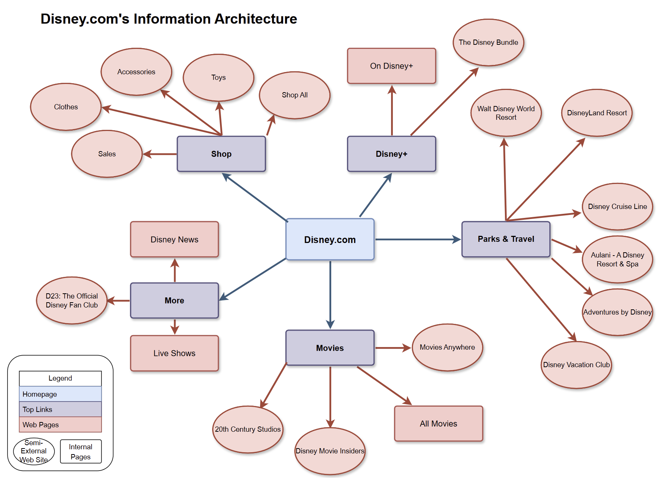

**StarsStreaming User Persona & Learning Curve**





**Obstacles**

* Limited Time to Research/Read Documentation
* After Hours to Need Help
* New Client

**Wants/Needs**

* Easy Access to Common Information
* 24 Hr Customer Assistance
* Child Lock/Security

**Savviness Scale**

Internet 

Streaming 

Research 

Device Variability 

**Helpful Suggestions**

Navigate to StarsStreaming Homepage

Contact Customer Support

**Demographics**

Amelia Korning

30 Years Old

Female

New York, USA

Customer Service Representative

Associates in Communications

**Biography**

Amelia is a mother of two children; One 2 year old boy and one 5 year old girl. Currently lives in New York state and is a Customer Service Representative for a Telephone Company. Received her Associates in Communications at Caygua Community College. Amelia is a potential new customer looking to learn how to subscribe to the service.

**Favorite Movies & Shows**

* Practical Magic
* The Little Mermaid
* Under the Tuscan Sun
* Friends

**Childrens’ Favorite Movies & Shows**

* Frozen
* Trollz
* Bluey

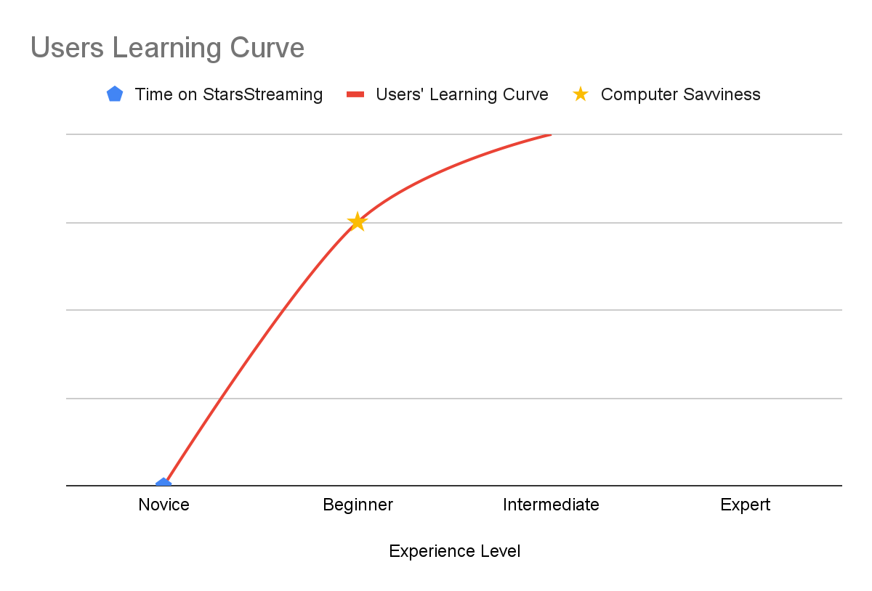

**Chart Description**

This chart displays the learning curve of the persona above.

This line shows the delta of no Experience on StarsStreaming versus the Persona’s Computer Savviness which gives the visual of the learning curve.

**StarsStreaming FAQs**

**What is StarsStreaming?**

StarsStreaming is a Paid Subscription Streaming Service that allows you to stream Movies, Shows, StarsStreaming Originals and much more

**What does StarsStreaming Include?**

All Subscription plans for StarsStreaming includes:

Movies

Shows

StarsStreaming Originals

StarsStreaming Shorts

StarsStreaming Premium will also include:

Unlimited Downloads on up to 5 different devices

No Advertisements

**How much is StarsStreaming?**

StarsStreaming(with Ads) is $7.99 per month

StarsStreaming Premium(without Ads) is $10.99 per month

**How do I sign up for StarsStreaming?**

Open StarsStreaming on your web browser

Click on “Sign Up”

Fill out the information on the form

Select your Plan

Click “Submit”

**I forgot my password, where do I find password help?**

Scroll to the bottom of StarsStreaming.com

Click on “Help”

Click on “Login”

Click on “Forgot my password”

**New User Memo**

| **To** | NewUser@EmailProvider.com |
| --- | --- |
| **Cc** | IT@StarsStreaming.com |
| **Bcc** |  |
| **Subject** | Welcome to StarsStreaming! |
| Dear [User First Name],  Thank you for subscribing to StarsStreaming!  Account Information  Your Username: [Username]  Your Subscription Plan: [UserSubPlan]  Monthly Subscription Fee: [UserSubFee]  Card on File: [Encrypted_UserPrimCard]  Here are some magical favorites to get you started:  [Popular_Movie Title], [Popular_Movie Title], [Popular_Movie Title]  If you need help, please go to [www.StarsStreaming.com/Help](http://www.starsstreaming.com/Help)  If you need to Cancel Service, please go to [www.StarsStreaming.com/Cancel](http://www.starsstreaming.com/Cancel)  Do not hesitate to reach out to any of our Customer Service Representatives. They are available by phone, email, or chat 24 hours a day.  Customer Service Contact Information  Phone: (315) 000-0000  Email: [CustService@StarsStreaming.com](mailto:CustService@StarsStreaming.com)  Chat: Click [Here](http://www.starsstreaming.com/Chat)  [www.StarsStreaming.Com](http://www.starsstreaming.com) (315) 123-4567 [Social Media Link] [Social Media Link] [Unsubscribe](http://www.starsstreaming.com/Unsubscribe) | |

**StarsStreaming Application Start-up Guide**



StarsStreaming

Magical Streaming Services, LLC

**Application Start-up Guide**

A quick guide on how to get and run the StarsStreaming Application

| **Author:** | Amber Taylor |
| --- | --- |
| **Revision:** | A |
| **Date Published:** | 06/11/2024 |
| **Scope:** | Downloading and installing the application, how to login, navigating through different categories, playing content, as well as account and application settings. |
| **Purpose:** | To give instructions on how to obtain and operate the StarsStreaming application. |

**Table of Contents**

Table of Contents Pg. 2

Downloading & Installing StarsStreaming App Pg. 3

Logging In Pg. 4

Browsing the StarsStreaming App Pg. 5 & 6

Playing Content Pg. 7

StarsStreaming Application Start-up Guide Pg. 2

**Downloading & Installing the StarsStreaming Application**

**Step One:**

On your mobile device, tap on either “Play Store” or “App Store” depending on if you have an Android or Apple device.

**Step Two:**

Search for “StarsStreaming” by using the search bar located at the top of Google Play Store or at the lower right on the App Store.

**Step Three:**

For Google Play Store: Tap on the StarsStreaming icon to be directed to the download page. Then, tap on the “Install” button.

For Apple App Store: Tap on the “Get” button which is located to the right of the StarsStreaming icon.

**Step Four:**

Look for the StarsStreaming application on your mobile device and open it by tapping on the icon.

StarsStreaming Application Start-up Guide Pg. 3

**How to Log onto the StarsStreaming Application**

**Step One:**

Locate the StarsStreaming application on your mobile device and tap the icon to open the application.

**Step Two:**

Tap on “Sign in”

If you do not have an account, please tap on “Create Account” and then follow the on-screen instructions.

**Step Three:**

Tap on the “Username” text field and enter your username.

**Step Four:**

Tap on the “Password” text field and enter your password.

**Step Five:**

Tap on “Log in”

If you have any issues logging into the application, please tap on “Login Issues” and choose the option that best fits your situation.

StarsStreaming Application Start-up Guide Pg. 4

**Browsing the StarsStreaming Application**

* **Homepage**
  + After you log into the StarsStreaming application, the first screen you see is the Homepage.
  + The Homepage shows two different categories.
    - **Recommended**
      * A selection of content that has been suggested to you based on your watch history.
    - **Recently Watched**
      * Your most recently watched content will be displayed here for ease of access.
* **Main Menu**
  + The Main Menu is located at the very top of the Homepage.
    - The Main Menu provides access to browse categories and to change settings.
      * **Categories**
        + Categories is a list of different genres to choose from.
        + Filtering by Type of Content, Genre, Year, Director, and length is available by tapping on the “Filter” button in the upper right-hand side of the screen.

StarsStreaming Application Start-up Guide Pg. 5

* + - * **Settings**
        + **App Settings**

You can find settings on Audio, Display, Pausing, Security, and Notifications when tapping on the "App Settings” button.

* + - * + **Account Settings**

To Change Your Password, Manage Profiles, Upgrade Subscription, and Cancel Subscription, tap on the “Account Settings” button.

To Browse the StarsStreaming application, you can choose from a small selection of recommended movies and TV shows that are displayed on the Homepage under the Recommended section. In addition, you may navigate to the Categories Screen by using the Main Menu to be able to view all content available or to choose a category or movie or show you would like to be displayed on screen.

StarsStreaming Application Start-up Guide Pg. 6

**Playing Content on the StarsStreaming Application**

**Step One:**

Choose a movie or show you would like to watch by browsing the StarsStreaming application and tapping on the icon of the movie or show you chose.

**Step Two:**

The Information Page of the movie or show will appear on screen, tap the “Play” button.

**Step Three:**

The media player will open and automatically begin playing the content.

**Media Player Options**

**Pause:** To pause the content, tap the screen and then tap the pause icon in the middle of the screen.

**Mute:** To mute the content, tap the screen and then tap the speaker icon at the bottom right of the screen.

**Fast Forward:** To fast forward the content, tap the screen and drag the ball at the bottom of your screen to the point in which you would like the content to resume.

**Rewind:** To rewind the content, tap the screen and drag the ball at the bottom of your screen to the point in which you would like the content to resume.

**Close Player:** To close the media player, tap the screen and tap on the “X” icon at the middle top of your screen.

StarsStreaming Application Start-up Guide Pg. 7

**StarsStreaming Style Guide**

**StarsStreaming Color Palette**

# **#152637**

≈ Big Stone

# **#324b7f**

≈ Chambray

# **#3010f5**

≈ Blue

# **#c9e3f7**

≈ Tropical Blue

# **#a3bfd8**

≈ Pigeon Post

**Font**

Arial

**Title**

**Header 1**

**Header 2**

Body

Footer

Indented Lists

* Lvl 1
  + Lvl 1.1
    - Lvl 1.2
* Lvl 2

**Company Name**

StarsStreaming

Magical Streaming Services, LLC

**Header**



**Icons**

  
  
  
**Profile Picture Background Layer**



**Release Notes**

StarsStreaming 2.0

June 12th, 2024

Check out what we have done!

We have added a requested feature that allows the filtering and sorting of content via the Categories screen. We have also been able to fix some bugs that include users having playback issues and receiving double emails.

We are also working on fixing an issue where the content’s audio keeps playing after the media player has been paused.

Take a look below for a short list of updates and fixes.

**Added Features**

* Filtering Content
  + Media Content can now be filtered and sorted from the Categories screen.

**Bug Fixes**

* Playback Issues: Fixed playback issue when user taps on the media player, no overlay appeared. Now, an overlay will appear with the options to play, pause, fastforward, rewind, and adjust sound.
* Double Email Notifications: Fixed a duplicating email issue to where users would receive two emails instead of one. Now, users will only get one email.

**Current Issues**

* Media audio keeps playing after content has been paused.

Previous Release Notes

June 1st, 2024

Previous Bug Fixes

* User login: Some users cannot log into the application right after signing up for a StarsStreaming subscription. Now, all users can log in after confirming their account through the email verification process.

Previous Issues

* Playback Issues: No overlay on media player.
* Double Email: Users receiving double emails.
* Media Audio: Audio keeps playing after content has been paused.